https://www.centurylink.com/wholesale/paperlessbilling.html
Go Green Paperless Billing
Wholesale: Products & Services
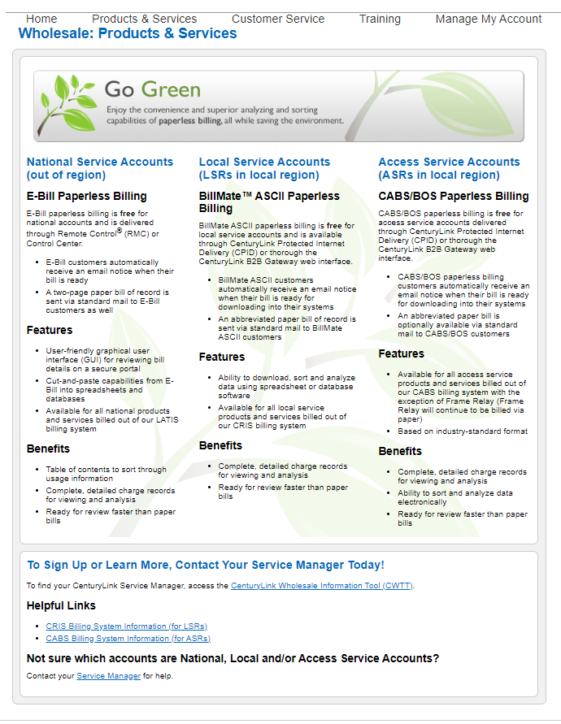
National Service Accounts  (out of region)  E-Bill Paperless Billing  E-Bill paperless billing is free for national accounts and is delivered through Remote Control® (RMC) or Control Center.  - E-Bill customers automatically receive an email notice when their bill is ready  - A two-page paper bill of record is sent via standard mail to E-Bill customers as well  Features  - User-friendly graphical user interface (GUI) for reviewing bill details on a secure portal  - Cut-and-paste capabilities from E-Bill into spreadsheets and databases  - Available for all national products and services billed out of our LATIS billing system  Benefits  - Table of contents to sort through usage information  - Complete, detailed charge records for viewing and analysis  - Ready for review faster than paper bills | Local Service Accounts  (LSRs in local region)  BillMate™ ASCII Paperless Billing  BillMate ASCII paperless billing is free for local service accounts and is available through CenturyLink Protected Internet Delivery (CPID) or through the CenturyLink B2B Gateway web interface.  - BillMate ASCII customers automatically receive an email notice when their bill is ready for downloading into their systems  - An abbreviated paper bill of record is sent via standard mail to BillMate ASCII customers  Features  - Ability to download, sort and analyze data using spreadsheet or database software  - Available for all local service products and services billed out of our CRIS Ensemble billing system  Benefits  - Complete, detailed charge records for viewing and analysis  - Ready for review faster than paper bills | Access Service Accounts  (ASRs in local region)  CABS/BOS Paperless Billing  CABS/ Bill Output Specifications (BOS) paperless billing is free for access service accounts delivered through CenturyLink Protected Internet Delivery (CPID) or through the CenturyLink B2B Gateway web interface.  - CABS/BOS paperless billing customers automatically receive an email notice when their bill is ready for downloading into their systems  - An abbreviated paper bill is optionally available via standard mail to CABS/BOS customers  Features  - Available for all access service products and services billed out of our CABS billing system with the exception of Frame Relay (Frame Relay will continue to be billed via paper)  - Based on industry-standard format  Benefits  - Complete, detailed charge records for viewing and analysis  - Ability to sort and analyze data electronically  - Ready for review faster than paper bills
To Sign Up or Learn More, Contact Your Service Manager Today!
To find your CenturyLink Service Manager, access the CenturyLink Wholesale Information Tool (CWTT).
Helpful Links
- CRIS Billing System Information (for LSRs)Ensemble Billing System Information (for LSRs)
- CABS Billing System Information (for ASRs)
Not sure which accounts are National, Local and/or Access Service Accounts?
Contact your Service Manager for help.
Last reviewed: March 12, 2024

